**AI19542 - DATA SCIENCE USING R - RECORD**



**DEPARTMENT OF ARTIFICIAL INTELLIGENCE AND MACHINE LEARNING**

**AI19542 – DATA SCIENCE USING R**

**RECORD**

**THIRD YEAR FIFTH SEMESTER 2024 - 2025**

**ODD SEMESTER**

|  |  |
| --- | --- |
| **Ex No:**1  **Date:** | **Basics of R – data types, vectors, factors, list and data**  **frames** |

# AIM:

To implement and understand the basics of R programming with its data types,

vectors, factors, list and data frames.

# ALGORITHM:

1. Start
2. Assign values in logical, numerical, character, complex and character in raw form to a variable v.
3. Print the class of v.
4. Assign a vector for subject Names, temperature and flu_status for three patients using

c() function and access the elements.

1. Create a factor using factor() with duplicate values and assign level with distinct values.
2. Display the specific element and check for certain values in factor.
3. Create a list using list() from the patient details and access the multiple elements.
4. Create a data frame using data.frame() with multiple vectors as features. Access the elements.
5. Create a matrix using matrix() with different allocations and access the elements.
6. Stop.

# PROGRAM:

#Data Types v<-TRUE

print(class(v)) v<-23.5

print(class(v)) v<-2L

print(class(v)) v<-2+5i

print(class(v)) v<-"TRUE"

print(class(v))

v<-charToRaw("Hello")

print(class(v))

#Vectors

subject_name<-c("John Doe","Jane Doe","Steven Grant") temperature<-c(98.1,98.6,101.4)

flu_status<-c(FALSE,FALSE,TRUE) temperature[2]

temperature[2:3] temperature[-2]

#Factors

gender<-factor(c("MALE","FEMALE","MALE")) gender

blood<-factor(c("O","AB","A"),levels=c("A","B","AB","O"))

blood[1:2]

symptoms<-factor(c("SEVERE","MILD","MODERATE"), levels=c("MILD","MODERATE","SEVERE"),

ordered=TRUE)

symptoms>"MODERATE"

#Lists

subject1<-list(fullname=subject_name[1], temperature=temperature[1], flu_status=flu_status[1], gender=gender[1], blood=blood[1], symptoms=symptoms[1])

subject1 subject1[2] subject1[[2]]

subject1$temperature subject1[c("temperature","flu_status")]

#Data Frames

pt_data<-data.frame(subject_name, temperature, flu_status, gender,blood,symptoms)

pt_data pt_data$subject_name

pt_data[c("temperature","flu_status")] pt_data[c(1,2),c(2,4)]

pt_data[,1] pt_data[,]

#Matrices

m<-matrix(c(1,2,3,4),ncol=2) print(m)

m<-matrix(c(1,2,3,4,5,6),nrow=3) print(m)

print(m[1,])

print(m[1,])

thismatrix <- matrix(c("apple", "banana", "cherry","orange"), nrow = 2, ncol = 2) for (rows in 1:nrow(thismatrix)) {

for (columns in 1:ncol(thismatrix)) {

print(thismatrix[rows, columns])

}

}

# OUTPUT:

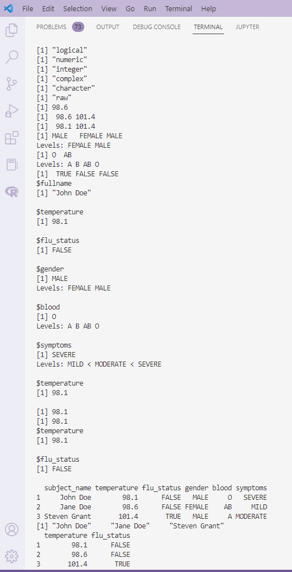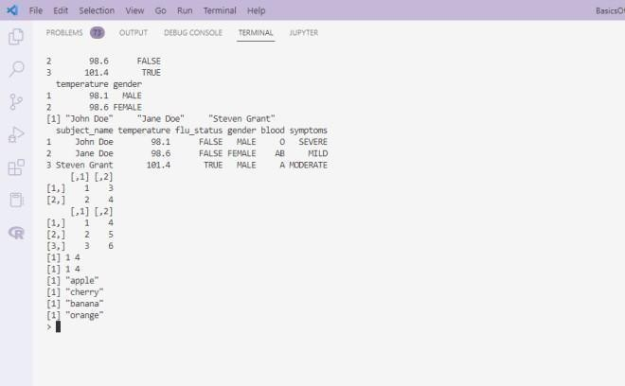

## Result:

Thus the R Script program to implement various data types, vectors, factors, lists and data frames is executed successfully and the output is verified.

**Diagnosis of Breast Cancer using KNN.**

**Ex no: 2**

**Date:**

## Aim:

To implement a R program to predict and diagnose Breast Cancer using KNN

algorithm.

## Algorithm:

1. Start
2. Read the csv file from the directory and store it in bcd variable.
3. Drop the first column id.
4. Change the diagnosis feature with categorical values B and M in a factor
5. Normalize the dataset.
6. Split the dataset for training and testing, with diagnosis as the response variable and the rest as the predictor variables.
7. Import the library “class” for knn classification.
8. Predict the knn model using knn() with 5 clusters with the corresponding training and testing data.
9. Display the confusion matrix and accuracy of the knn model.
10. Stop

**PROGRAM:**

bcd<-read.csv("../input/breast-cancer-dataset/Breast_Cancer.csv", stringsAsFactors=FALSE) bcd<-bcd[-1]

bcd$diagnosis<-factor(bcd$diagnosis, levels=c("B","M"), labels=c("Benign","Malignant"))

normalize<-function(x){

return (x-min(x)) / (max(x)- min(x))

}

bcd_n <- as.data.frame(lapply(bcd[2:31], normalize)) x_train <- bcd_n[1:469,]

x_test <- bcd_n[470:569,] y_train <- bcd[1:469,1] y_test <- bcd[470:569,1] library(class)

y_pred<-knn(train=x_train,test=x_test,cl=y_train,k=5) tbl=table(x=y_test,y=y_pred)

tbl

accuracy = sum(diag(tbl))

**OUTPUT:**

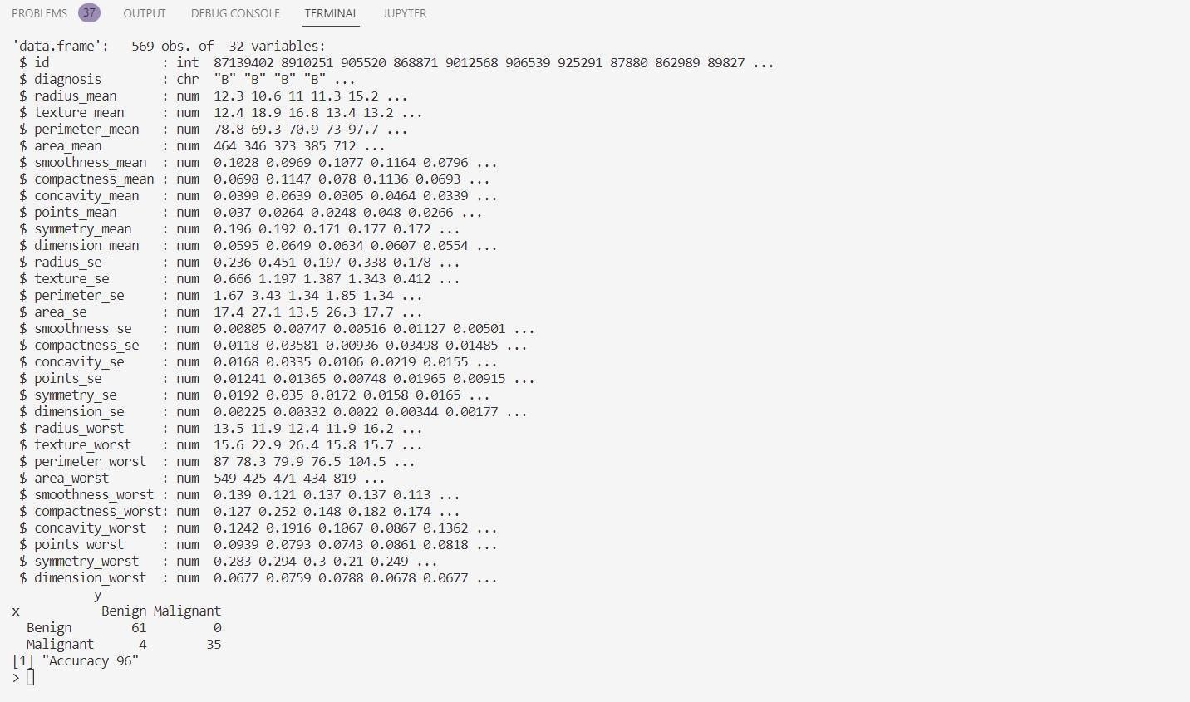

## Result:

Thus the R Script program to implement diagnosis of Breast Cancer using K-Nearest Neighbour algorithm is executed successfully and the output is verified.

**Filtering Mobile phone spam using Naïve Bayes**

**Ex No: 3**

**Date:**

# AIM:

To implement a R program to Filter Mobile phone spam using Naïve Bayes.

# ALGORITHM:

1. Start
2. Import the csv file and store the dataframe in “Sms”. Have a glimpse at the structure

of the data frame.

1. Remove the unneccesary columns which is from column 3 to 5.
2. Convert the labels as factors.
3. Remove special characters from the dataset and retain only alpha numeric characters

using alnum in str_replace_all() from “stringr” package.

1. Create a volatile corpus VCorpus() for text mining from the source object of “v2”

which is extracted using VectorSource() .

1. Create a DocumentTermMatrix() to split the SMS message into individual Components.
2. Create training and testing dataset with the split ratio 0.75.
3. Find the frequent terms which appear for atleast 5 times in DocumentTermMatrix in training and testing dataset respectively.
4. Train the model using naiveBayes() from e1071 library.
5. Evaluate the model Performance.
6. Print the confusion matrix and Accuracy of the model.
7. Stop.

# PROGRAM:

sms <- read.csv("../input/spam-ham-dataset/spam.csv", stringsAsFactors=FALSE) str(sms)

sms <-sms[-3:-5]

sms$v1 <- factor(sms$v1) library(stringr)

sms$v2 = str_replace_all(sms$v2, "[^[:alnum:]]", " ") %>% str_replace_all(.,"[

]+", " ")

library(tm)

sms_corpus <- VCorpus(VectorSource(sms$v2))

print(sms_corpus)

print(as.character(sms_corpus[[6]]))

sms_dtm <- DocumentTermMatrix(sms_corpus, control = list (tolower=TRUE,removeNumbers=TRUE,stopwords=TRUE,removePunctuations=TRUE,stemmi ng=TRUE))

x_train <- sms_dtm[1:4169, ] x_test <- sms_dtm[4170:5572, ] y_train <- sms[1:4169, ]$v1 y_test <- sms[4170:5572, ]$v1

sms_freq_word_train <- findFreqTerms(x_train, 5) sms_freq_word_test <- findFreqTerms(x_test, 5) x_train<- x_train[ , sms_freq_word_train]

x_test <- x_test[ , sms_freq_word_test]

convert_counts <- function(x) {x <- ifelse(x > 0, "Yes", "No")} x_train <- apply(x_train, MARGIN = 2,convert_counts)

x_test <- apply(x_test, MARGIN = 2,convert_counts)

library(e1071)

model <- naiveBayes(x_train, y_train,laplace=1)

y_pred <- predict(model, x_test) cm = table(y_pred, y_test) print(cm)

acc = sum(diag(cm))/sum(cm)

print(paste("Accuracy: ",acc*100,"%"))

# OUTPUT:

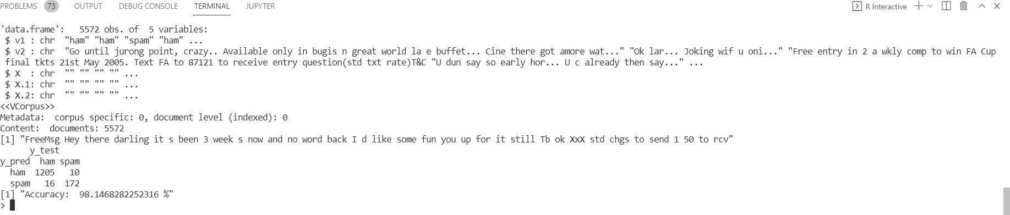

**RESULT:**

Thus the R program to implement filtering of Mobile phone spam using Naïve Bayes is executed successfully and the output is verified.

**Risky Bank Loans using Decision Trees**

**Ex No:4**

**Date:**

**AIM:**

To implement a R program to find Risky Bank loans using Decision Tree.

# ALGORITHM:

1. Start
2. Import the dataset credit.csv and display the structure of the dataset.
3. Display the table to find the range of values and find the missing values.
4. Factorise the default column and set seed of 123.
5. Split the dataset for training and testing in the ratio of 0.8, with “default” as the response variable, and the rest as predictor variables.
6. Import the library C5.0 for implementing decision tree.
7. Train the decision tree model using C5.0 function for the training dataset.
8. Test the model to predict using predict(). Print the confusion matrix.
9. Print the accuracy of the decision tree model.
10. Stop

# PROGRAM:

credit <- read.csv("credit.csv") str(credit) table(credit$savings_balance) summary(credit$amount) credit$default <- factor(credit$default) set.seed(123)

train_sample <- sample(1000, 800)

str(train_sample)

x_train <- credit[train_sample, -17] x_test <- credit[-train_sample, -17] y_train <- credit[train_sample, 17] y_test <- credit[-train_sample, 17] library(C50)

model <- C5.0(x_train,y_train)

summary(model)

y_pred <- predict(model,x_test) cm = table(y_pred,y_test) print(cm) acc=sum(diag(cm))/sum(cm)

print(paste("Accuaracy: ",acc*100,"%"))

# OUTPUT:

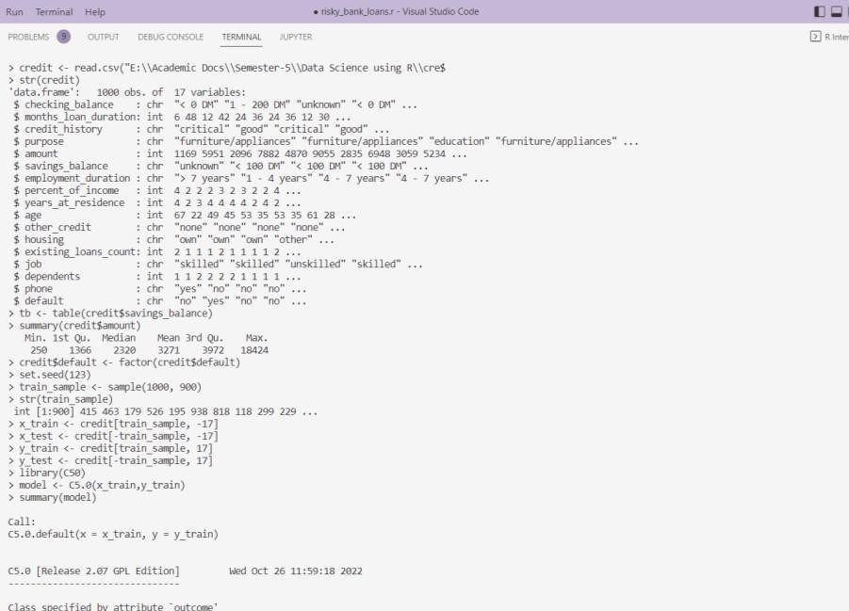

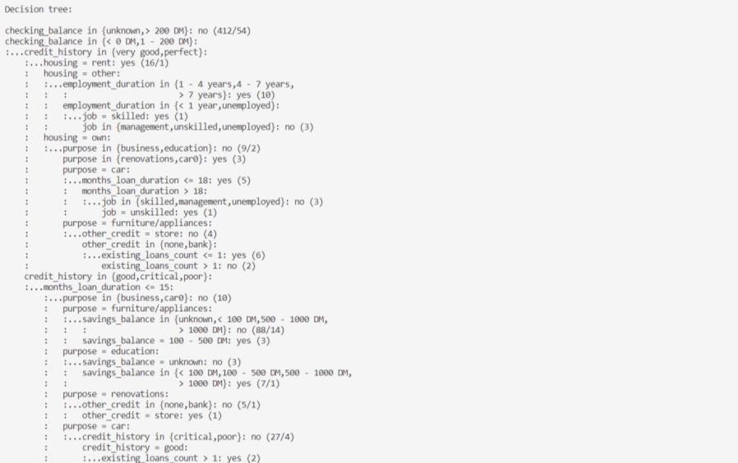

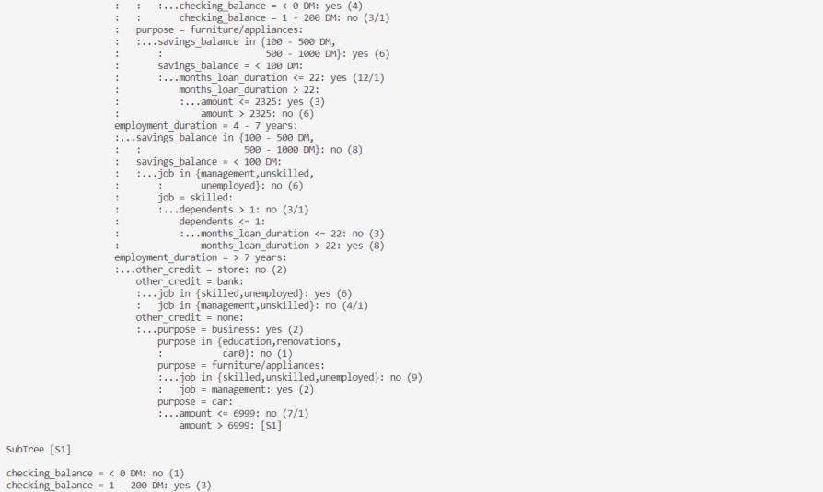

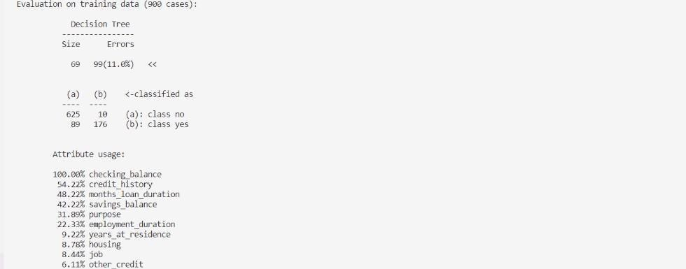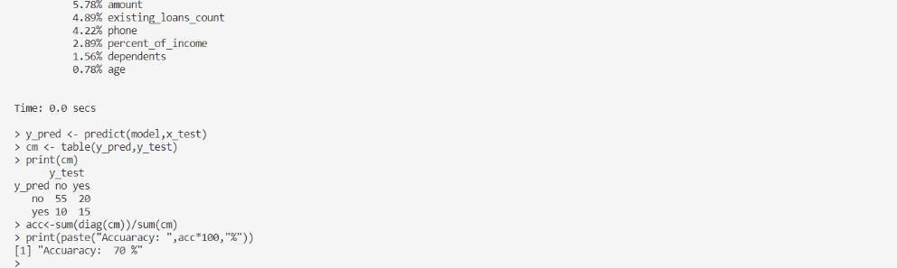

**RESULT:**

Thus the R program to find Risky Bank loans using Decision Tree is executed successfully and the output is verified.

**Medical Expense with Linear Regression.**

**Ex No: 5**

**Date:**

# AIM:

To implement a R program to predict Medical Expense using Linear Regression

# ALGORITHM:

1. Start
2. Load the Insurance dataset and analyse the structure of the dataset.
3. Get the summary statistics.Check whether the distribution is right-skewed or left

skewed by comapring the mean and median. Verify the same using histogram.

1. Check the distribution of “region” using table.
2. Create a correlation matrix of “age”, “bmi”, “children”, “expenses”.
3. To determine the pattern of the dataset, use scatterplot using pairs() for “age”, “bmi”, “children”, “expenses”.
4. To display a more informative scatterplot use pairs.panel() from “psych” library.
5. Fit the linear regression model using lm() with expenses as the dependent variable.
6. Evaluate the model performance using summary().
7. To improve the model performance, square the age variable as age2 and bmi30 is 1 if

bmi>=30 else 0.

1. Train the model with age + age2+bmi30 as also as the independent variables.
2. Evaluate the model performance for model2 using summary().
3. Stop.

# PROGRAM:

insurance<-read.csv("insurance.csv",stringsAsFactors = TRUE) str(insurance)

summary(insurance$expenses) hist(insurance$expenses) table(insurance$region)

cor(insurance[c("age","bmi","children","expenses")])

pairs(insurance[c("age","bmi","children","expenses")]) library(psych) pairs.panels(insurance[c("age","bmi","children","expenses")])8

ins_model <- lm(expenses ~ age + children + bmi + sex + smoker + region, data = insurance)

ins_model

summary(ins_model) insurance$age2 <- insurance$age^2

insurance$bmi30 <- ifelse(insurance$bmi >= 30,1,0)

expenses ~ bmi30*smoker

expenses ~ bmi30+smokeryes+bmi30:smokeryes

ins_model2 <- lm(expenses ~ age+age2+children+bmi+sex+bmi30*smoker+region, data=insurance)

summary(ins_model2)

# OUTPUT:

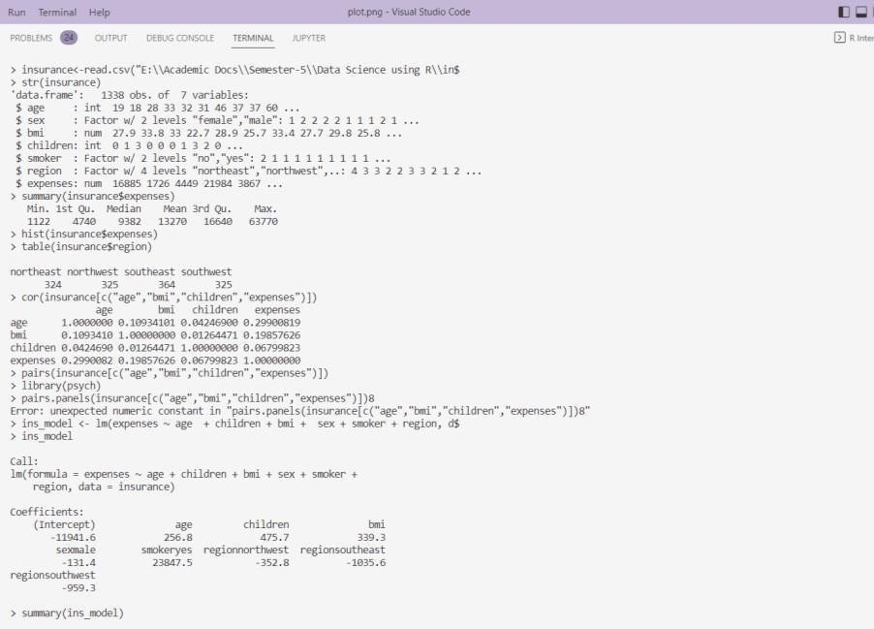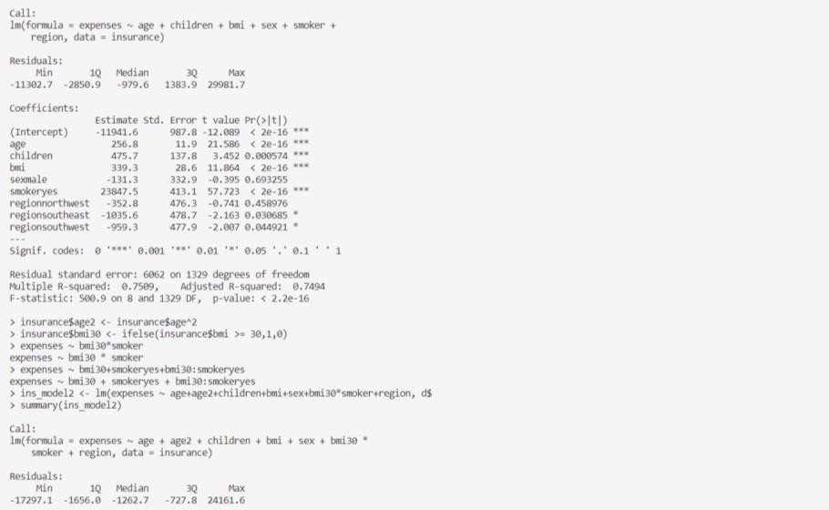

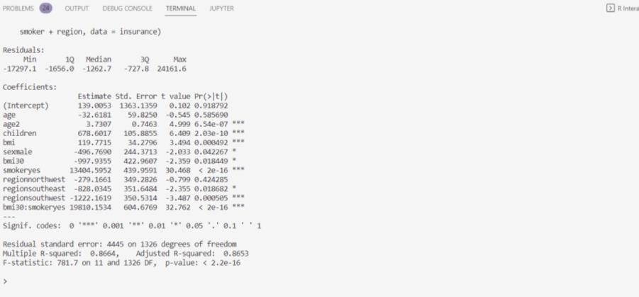

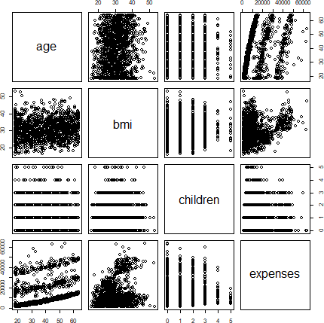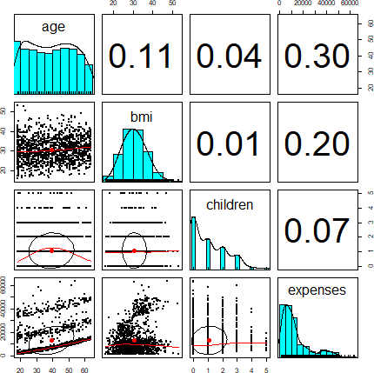

**RESULT:**

Thus the R program to predict medical expenses using linear regression is

executed successfully and the output is verified.

**Modeling strength of concrete.**

**Ex No: 6**

**Date:**

# AIM:

To build a predictive model for the compressive strength of concrete based on its composition and age using linear regression in R.

# ALGORITHM:

1. Start
2. Load the Insurance dataset and check its structure.
3. Get summary statistics and check skewness using mean, median, and histogram.
4. Check the distribution of “region” using a table.
5. Create a correlation matrix for “age,” “bmi,” “children,” and “expenses.”
6. Use scatterplots to examine relationships among “age,” “bmi,” “children,” and “expenses.”
7. Fit an initial linear model with “expenses” as the target, then improve by adding `age2`

(age squared) and `bmi30` (1 if bmi >= 30) and re-evaluate.

1. Stop

# PROGRAM:

library(caret) library(ggplot2)

data <- read.csv("concrete.csv") head(data)

sum(is.na(data)) set.seed(123)

trainIndex <- createDataPartition(data$CompressiveStrength, p =

0.8, list = FALSE)

trainData <- data[trainIndex,] testData <- data[-trainIndex,]

model <- lm(CompressiveStrength ~ ., data = trainData)

summary(model)

predictions <- predict(model, newdata = testData)

mae <- mean(abs(predictions - testData$CompressiveStrength))

print(paste("Mean Absolute Error:", round(mae, 2)))

ggplot() +

geom_point(aes(x = testData$CompressiveStrength, y = predictions), color = 'blue') +

geom_abline(slope = 1, intercept = 0, linetype = "dashed", color = "red") +

labs(title = "Predicted vs Actual Compressive Strength", x = "Actual Strength",

y = "Predicted Strength") + theme_minimal()

# OUTPUT:

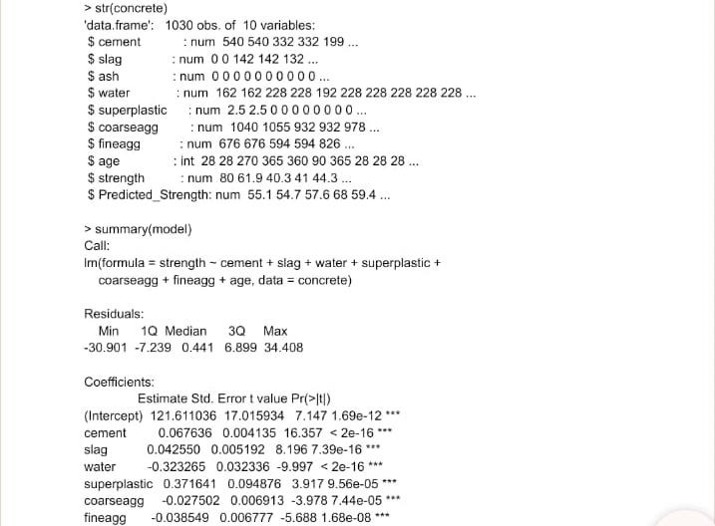

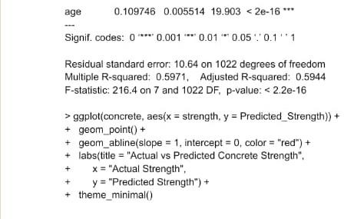

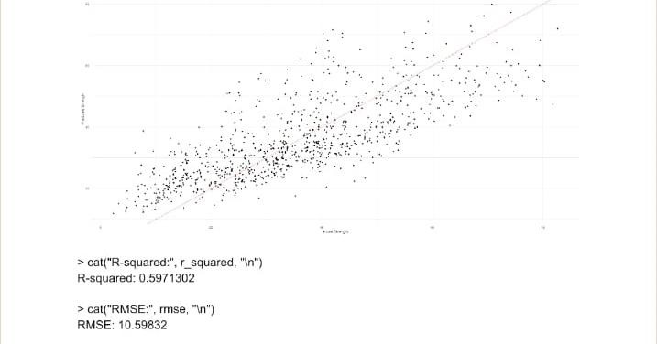

**RESULT:**

Thus the R Script program to implement Modeling strength of concrete is executed successfully and the output is verified.

**Identification of frequently Purchased groceries with Apriori algorithm.**

**Ex No: 7**

**Date:**

# AIM:

To identify frequent itemsets of grocery items that are commonly purchased together using the Apriori algorithm. This will help in understanding customer buying patterns and optimizing store layout or inventory.

# ALGORITHM:

1. Start
2. Load Data: Load the transaction dataset (assume each transaction is a list of items purchased).
3. Data Preprocessing: Convert the data into a transactional format suitable for

association rule mining.

1. Set Parameters: Define minimum support and confidence levels for the Apriori algorithm.
2. Apply Apriori Algorithm: Use the Apriori algorithm to find frequent itemsets.
3. Generate Association Rules: Extract association rules from the frequent itemsets based on support and confidence thresholds.
4. Analyze Results: Sort and filter rules to identify the most frequently purchased item combinations.
5. Stop

# PROGRAM:

if(!require(arules)) install.packages("arules", dependencies=TRUE) library(arules)

data("Groceries")

summary(Groceries)

min_support <- 0.01 # Example: at least 1% of transactions

min_confidence <- 0.5 # Example: at least 50% confidence

frequent_itemsets <- apriori(Groceries, parameter = list(supp = min_support, conf = min_confidence))

summary(frequent_itemsets) inspect(frequent_itemsets[1:10])

rules <- apriori(Groceries, parameter = list(supp = min_support, conf = min_confidence,

target = "rules")) summary(rules)

inspect(sort(rules, by = "confidence")[1:10]) # Display top 10 rules by confidence if(!require(arulesViz)) install.packages("arulesViz", dependencies=TRUE) library(arulesViz)

plot(rules, method = "graph", control = list(type = "items"))

# OUTPUT:

## Summary of the Groceries Dataset

transactions as itemMatrix in sparse format with 9835 rows (elements/itemsets/transactions) and 169 columns (items) and a density of 0.02609146

most frequent items:

whole milk other vegetables rolls/buns soda yogurt (Other)

2513 1903 1809 1715 1372 34055

## Frequent Itemsets:

set of 50 itemsets

example of first 10 itemsets (sorted by support): items support

1. {whole milk} 0.25551601
2. {other vegetables} 0.19349263
3. {rolls/buns} 0.18393493
4. {soda} 0.17437722
5. {yogurt} 0.13950178
6. {whole milk, other vegetables} 0.0751
7. {whole milk, yogurt} 0.0561

**Association Rules (Top 10 by Confidence)**: set of 10 rules

example of first 10 rules (sorted by confidence): lhs rhs support confidence lift

1. {yogurt} => {whole milk} 0.0561 0.4032 1.57
2. {rolls/buns} => {whole milk} 0.0567 0.3084 1.21
3. {soda} => {whole milk} 0.0569 0.3058 1.20
4. {tropical fruit} => {whole milk} 0.0519 0.2674 1.03
5. {other vegetables} => {whole milk} 0.0751 0.3926 1.53

# RESULT:

Thus the R program to Identification of frequently Purchased groceries with Apriori

algorithm is executed successfully and the output is verified.

**Finding Teen Segments of Market**.

**Ex No: 8**

**Date:**

# AIM:

The aim of this process is to identify and segment the teen demographic in a market based on behavior, preferences, or other relevant characteristics for targeted marketing or product development.

# ALGORITHM:

1. START: Collect raw data from sources relevant to the teen market (e.g., social media

data, survey responses).

1. PREPROCESSING: Clean the data (e.g., remove missing values, correct errors).
2. SELECT FEATURES: Choose features that help in segmentation (e.g., age,

purchase patterns, interests).

1. APPLY CLUSTERING ALGORITHM: Run clustering algorithms (e.g., K-Means or DBSCAN) to create market segments.
2. EVALUATE MODEL: Evaluate the clustering performance using a scoring metric (e.g., silhouette score).
3. VISUALIZE DATA: Visualize the segmented data to understand different groups.
4. EXTRACT INSIGHTS: Identify unique patterns and preferences within each segment.
5. STOP: Develop targeted marketing strategies based on the insights from the segmentation.
6. This approach allows businesses to better understand the teen market and tailor their products or marketing campaigns accordingly.

# PROGRAM:

library(dplyr) library(ggplot2) library(corrplot)

load_data <- function(file_path) { df <- read.csv(file_path) return(df)

}

preprocess_data <- function(df) { # Check for missing values print(colSums(is.na(df)))

df[is.na(df)] <- 0 # Fill missing values with 0

return(df)

}

analyze_segments <- function(df) { # Example: Segment by gender gender_counts <- table(df$gender) print("Gender Distribution:") print(gender_counts)

interest_features <- c('basketball', 'football', 'soccer', 'softball', 'volleyball',

'swimming', 'cheerleading', 'baseball', 'tennis',

'cute', 'sexy', 'hot', 'kissed', 'dance',

'band', 'marching', 'music', 'rock', 'god',

'church', 'jesus', 'bible', 'hair', 'dress',

'blonde', 'mall', 'shopping', 'clothes', 'hollister', 'abercrombie', 'die', 'death', 'drunk', 'drugs')

corr_matrix <- cor(df[interest_features])

corrplot(corr_matrix, method = "color", tl.col = "black", tl.srt = 45)

}

main <- function(file_path) { df <- load_data(file_path) df <- preprocess_data(df) analyze_segments(df)

}

main('path_to_your_file.csv')

# OUTPUT:

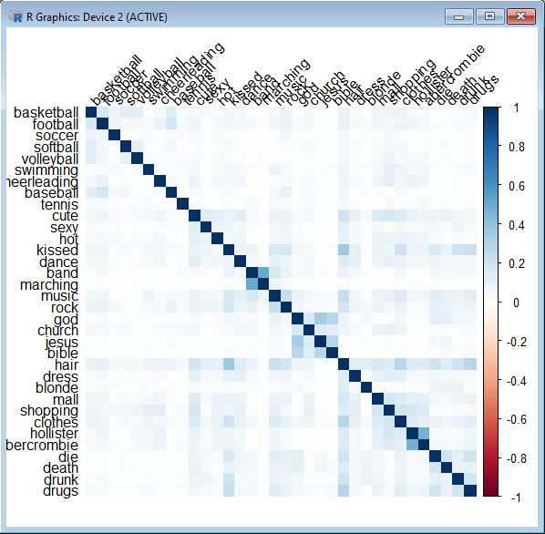

**RESULT:**

Thus the R program to Finding Teen Segments of Market is executed successfully and the

output is verified.

**Tuning stock models for better performance.**

**Ex No: 9**

**Date:**

# AIM:

The aim is to enhance the predictive performance of stock market models by optimizing hyperparameters, improving data features, and using techniques like cross- validation and model selection to better forecast stock prices or trends.

# ALGORITHM:

1. Start
2. Data Collection: Gather historical stock data (e.g., price, volume, market sentiment, technical indicators).
3. Data Preprocessing: Clean the data by handling missing values, normalizing features, and creating relevant indicators (e.g., moving averages, RSI).
4. Feature Engineering: Create new features based on existing data to improve model

predictions (e.g., lagged values, percentage changes, or volatility).

1. Model Selection: Choose an appropriate model (e.g., Linear Regression, Decision Trees, Random Forest, LSTM for time series).
2. Hyperparameter Tuning: Tune the hyperparameters of the model using techniques like Grid Search or Random Search to optimize performance.
3. Cross-Validation: Implement cross-validation (e.g., k-fold) to ensure that the model generalizes well on unseen data.
4. Model Evaluation: Evaluate the model's performance using metrics like RMSE,

MAE, or accuracy, and compare the results with different models.

1. Model Refinement: Refine the model by adjusting hyperparameters further,

adding/removing features, or testing different algorithms to achieve better results

1. End.

# PROGRAM:

library(randomForest) library(Metrics)

data <- read.csv("C:/Users/AI_LAB/Desktop/77/stock.csv")

if (is.null(data)) {

stop("Data not loaded. Please check the file path.")

}

str(data)

data$Closing.Volume <- as.numeric(as.character(data$Closing.Volume)) # Update based on

your target variable

data <- na.omit(data)

set.seed(123)

train_index <- sample(1:nrow(data), 0.8 * nrow(data))

train_data <- data[train_index, ] test_data <- data[-train_index, ]

rf_model <- randomForest(Closing.Volume ~ ., data = train_data, ntree = 100) predictions <- predict(rf_model, newdata = test_data)

actuals <- test_data$Closing.Volume

mae <- mean(abs(predictions - actuals)) rmse <- sqrt(mean((predictions - actuals)^2)) cat("Mean Absolute Error:", mae, "\n") cat("Root Mean Squared Error:", rmse, "\n")

plot(test_data$Date, actuals, type = 'l', col = 'blue', ylim = range(c(actuals, predictions)),

xlab = 'Date', ylab = 'Closing Price', main = 'Actual vs Predicted Closing Prices') lines(test_data$Date, predictions, col = 'red')

legend("topright", legend = c("Actual", "Predicted"), col = c("blue", "red"), lty = 1)

# OUTPUT:

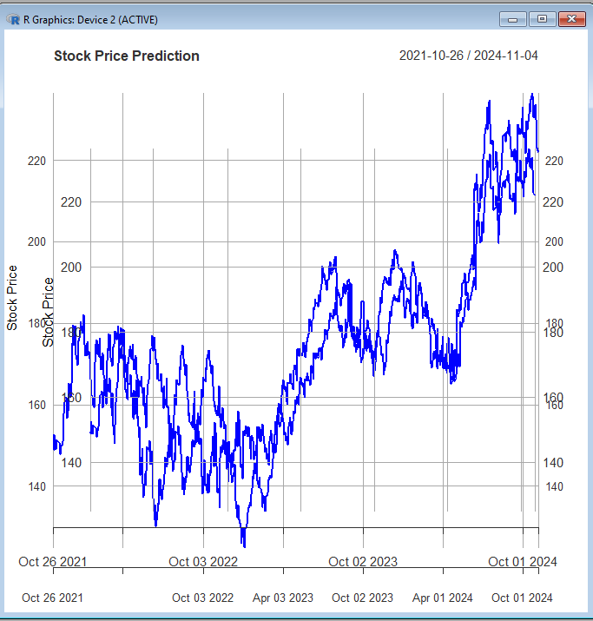

**RESULT:**

Thus the R program to Tuning stock models for better performance is executed successfully and the output is verified.